Software Requirements Specification

Version 1.0

Thegioididong Store

Group 1

HCM22_CPL_JAVA_03

Thành Viên

Lê Hoàng Hưng

Nguyễn Anh Vũ

Võ Tấn Sang

Bùi Ngọc Thạch

Trần Hoài Phong

Lương Tống Vĩnh Khang

MỤC LỤC

**1.0. Introduction 2**

**1.1. Purpose 2**

**1.2. Project scope 2**

**1.3. Glossary 2**

**2.0. Overall Description. 2**

**2.1 System Environment 2**

**2.2 Functional Requirements Specification 3**

**Figure 1 – Thegioididong Store System Use Case 3**

**2.2.1. Thegioididong Admin Use Case 3**

**2.2.2. Thegioididong Customer Use Case 7**

**3.0. Requirements Specification 13**

**Admin Login 14**

**Admin Create Product 14**

**Admin Update Product 15**

**Admin Update Product 15**

**Admin View Detail Product 16**

**Admin Order comfirm 16**

**Admin Product List 17**

**Admin View Detiail Product 17**

**Customer Search Product 18**

**Customer Comment 18**

**Customer Add To Cart 19**

**Customer View Cart 19**

**Customer Update Cart 20**

**Customer Check Out 20**

**Customer Order Product 21**

**Figure 2 – Thegioididong Store System Class Diagram 22**

**Figure 3 – Thegioididong Store System architecture 23**

**Figure 4 – Thegioididong Store System Package 24**

# 1.0. Introduction

## 1.1. Purpose

The purpose of this document is to present a detailed description of the Thegioididong Store System . It will explain the purpose and features of the system, the interfaces of the system, what the system will do, the constraints under which it must operate and how the system will react to external stimuli. This document is intended for both the stakeholders and the developers of the system and will be proposed to the potential clients for its approval.

## 1.2. Project scope

This software product is the website for the shopper and sales manager of thegioididong store.

## 1.3. Glossary

|  |  |
| --- | --- |
| **Term** | **Definition** |
| Administrator | User can login to update sales web data |
| Customer | Users search for product information and make purchases |

# 2.0. Overall Description.

## 2.1 System Environment

End users could be project managers, quality assurance team and other project members. There are more than 500 possible users.

TBD

## 2.2 Functional Requirements Specification

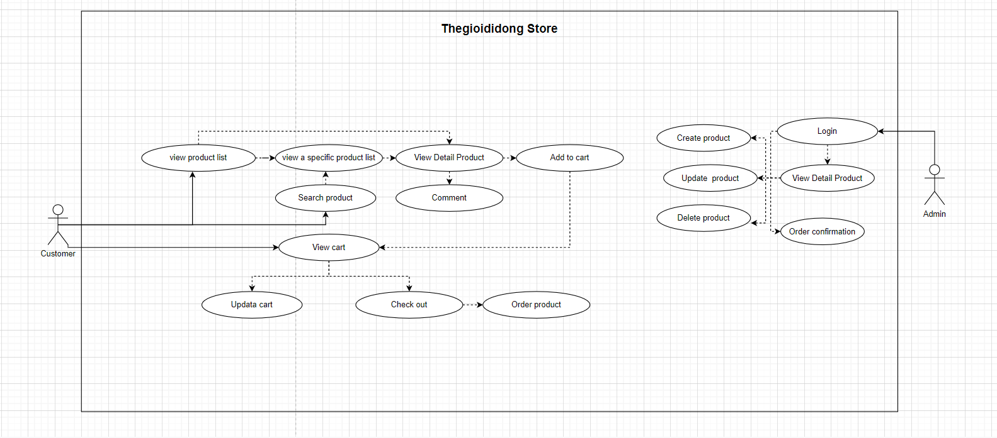

### Figure 1 – Thegioididong Store System Use Case

This section outlines the use cases for each of the active user separately.

## 2.2.1. Thegioididong Admin Use Case

#### Use case : Admin Login

**Diagram :**

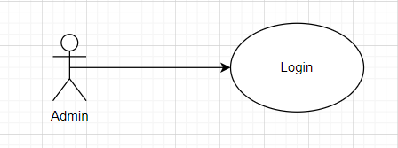

**Brief Description :** The admin accesses the Thegioididong website to login.

**Initial step-by-step description**

Before starting to use, the user (administrator) accesses the login page on Thegioididong website.

1. Administrator accesses the login page.
2. Admin add, edit, delete products
3. Admin confirm order

#### Use case : Admin Create Product

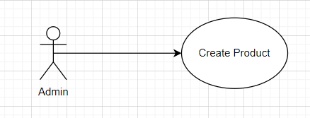

**Brief Description**

The admin accesses the Thegioididong website to Create product.

**Initial Step-By-Step Description**

Before this use case can be initiated, the user has already accessed the Thegioididong website with role admin.

1. The admin accesses to add product page.
2. The admin fills new product information and click add product.
3. The system insert new product to database and clear form.
4. The system allows the admin to perform other activities.

#### Use Case: Update product

**Diagram:**

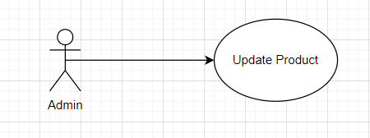

**Brief Description**

Admin access Thegioididong to update products.

**Initial step-by-step description**

Admin needs to login to use this function

1. Admin access the homepage.
2. The system redirects to the list of all products.
3. Admin click edit product.
4. Administrator clicks “Save”.
5. The system updates information into the database.
6. The system returns to the home page.

#### Use Case: Delete product

**Diagram:**

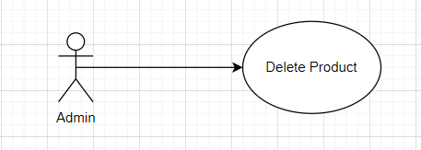

**Brief Description**

Admin accesses the Thegioididong to delete product.

**Initial Step-By-Step Description**

Admin need to login to use this function

1. Admin accesses the home page.
2. System redirects to list all products.
3. Admin clicks “Xóa” button on a product.
4. System redirects to confirm page.
5. Admin clicks “Đồng ý”.
6. System update information in database.
7. System return to home page.

#### Use case : Admin View Detail Product

**Diagram :**

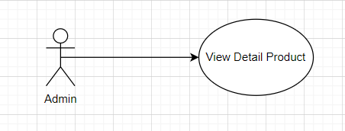

**Brief Description**

The admin accesses the Thegioididong website to view detail product.

**Initial Step-By-Step Description**

Admin need to login to use this function

1. Admin accesses the home page.
2. System redirects to list all products.
3. Admin clicks on a specific product.
4. System redirects to product details page.
5. System shows product details.
6. Admin can edit product’s information.
7. Admin clicks “Lưu”.
8. System update information in database.
9. System return to home page.

#### Use Case: Order comfirm

**Diagram:**

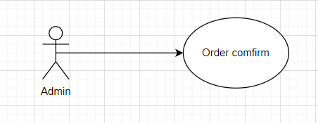

**Brief Description**

Admin login to the website and confirm the order

**Initial step-by-step description**

Admin needs to login to use this function

1. Admin access the homepage.
2. The system redirects to the shopping cart.
3. Admin click confirm or cancel the order.
4. Administrator clicks “Save”.
5. The system updates information into the database.
6. The system returns to the home page.

### 2.2.2. Thegioididong Customer Use Case

#### Use case : View Product List

**Diagram :**

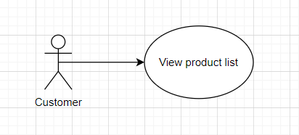

**Brief Description**

Customer access the web to see the product list

**Initial step-by-step description**

1. Customer access to the web.
2. The home page switching system.
3. Customer view product list

#### Use case : view a specific product list

**Diagram :**

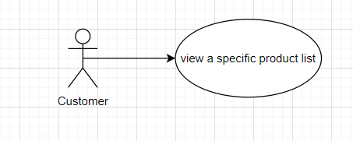

**Brief Description**

Customers visit the website to see a list of specific products

**Initial step-by-step description**

1. Customer access to the web.
2. Home page conversion system.
3. Customers select the product they want to view to see the product list

#### Use case : view a specific product list

**Diagram :**

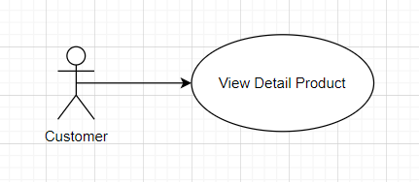

**Brief Description**

Customers visit the website to see a detailed list of products

**Initial step-by-step description**

1. Customer access to the web.
2. Home page conversion system.
3. Customer 1 product
4. The system moves to the specific details page of that product

#### Use case : Search product

**Diagram :**

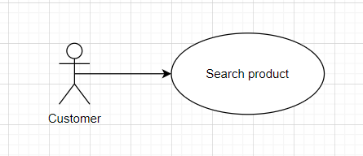

**Brief Description**

Customers visit the website looking for the product they are looking for

**Initial step-by-step description**

1. Customer access to the web.
2. Home page conversion system.
3. Customer searches for a product
4. The system goes to the specific details page of that product

#### Use case : Comment

**Diagram :**

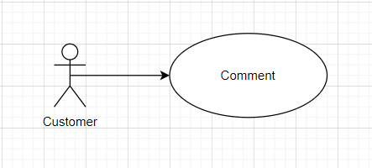

**Brief Description**

Customers visit the website to rate the product

**Initial step-by-step description**

1. Customer access to the web.
2. Home page conversion system.
3. Customer chooses 1 product
4. The system goes to that product detail page
5. Customers can comment below the product

#### Use case : Add to cart

**Diagram :**

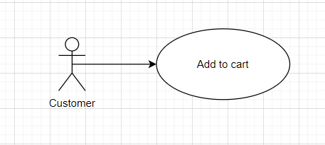

**Brief Description**

Customers visit the website to add products to the cart

**Initial step-by-step description**

1. Customer access to the web.
2. Home page conversion system.
3. Customer chooses 1 product
4. Customer adds that product to cart

#### Use case : View cart

**Diagram :**

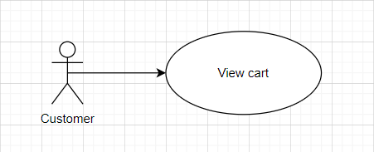

**Brief Description**

Customers visit the website to see what products are in the cart

**Initial step-by-step description**

1. Customer access to the web.
2. Home page conversion system.
3. Customer chooses to add to cart
4. The system redirects to the shopping cart page
5. The system displays products in the cart

#### Use case : Update cart

**Diagram :**

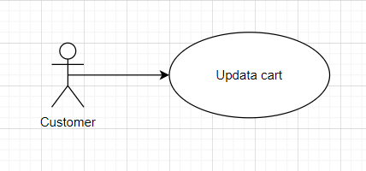

**Brief Description**

Customers visiting the website access the shopping cart and edit the shopping cart

**Initial step-by-step description**

1. Customer access to the web.
2. Home page conversion system.
3. Customer chooses to add to cart
4. The system redirects to the shopping cart page
5. The system displays products in the cart
6. Customers choose to buy or not

#### Use case : Check out

**Diagram :**

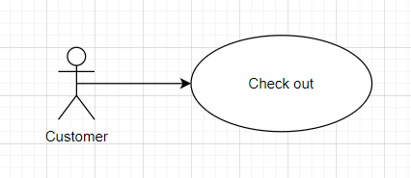

**Brief Description**

Customers accessing the website access the shopping cart and choose the method

**Initial step-by-step description**

1. Customer access to the web.
2. Home page conversion system.
3. Customer chooses to add to cart
4. The system redirects to the shopping cart page
5. The system displays products in the cart
6. Customers choose payment method
7. The system switches to the order page

#### Use case : Order product

**Diagram :**

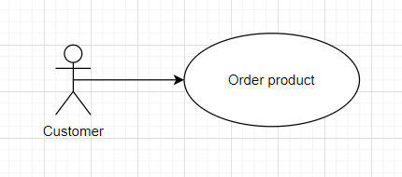

**Brief Description**

Customers visit the website to access the shopping cart and choose to pay

**Initial step-by-step description**

1. Customer access to the web.
2. Home page conversion system.
3. Customer chooses to add to cart
4. The system redirects to the shopping cart page
5. The system displays products in the cart
6. Customer chooses a payment method
7. The system switches to the order page
8. Customer selects the order button

# 3.0. Requirements Specification

**Functional Requirements:**

The Logical Structure of the Data is contained in Section 3.2.1.

## Admin Login

|  |  |
| --- | --- |
| **Use Case Name** | Admin Login |
| **XRef** | Section 2.2.1, Admin Login |
| **Trigger** | The user accesses the login page of Thegioididong website |
| **Precondition** | The login form display |
| **Basic Path** | 1. Administrator accesses the login page. 2. Admin add, edit, delete products 3. Admin confirm order |
| **Alternative Paths** | None |
| **Postcondition** | None |
| **Exception Paths** | None |
| **Other** | None |

## Admin Create Product

|  |  |
| --- | --- |
| **Use Case Name** | Admin Create Product |
| **XRef** | Section 2.2.1, Admin Create Product |
| **Trigger** | The admin accesses the Thegioididong website |
| **Precondition** | Login |
| **Basic Path** | 1. The admin accesses to add product page. 2. The admin fills new product information and click add product. 3. The system insert new product to database and clear form. 4. The system allows the admin to perform other activities. |
| **Alternative Paths** | None |
| **Postcondition** | None |
| **Exception Paths** | None |
| **Other** | None |

## Admin Update Product

|  |  |
| --- | --- |
| **Use Case Name** | Admin Update Product |
| **XRef** | Section 2.2.1, Admin Create Product |
| **Trigger** | The admin accesses the Thegioididong website |
| **Precondition** | Login |
| **Basic Path** | 1. Admin access the homepage. 2. The system redirects to the list of all products. 3. Admin click edit product. 4. Administrator clicks “Save”. 5. The system updates information into the database. 6. The system returns to the home page. |
| **Alternative Paths** | None |
| **Postcondition** | None |
| **Exception Paths** | None |
| **Other** | None |

## Admin Update Product

|  |  |
| --- | --- |
| **Use Case Name** | Admin Delete Product |
| **XRef** | Section 2.2.1, Admin Delete Product |
| **Trigger** | The admin accesses the Thegioididong website |
| **Precondition** | Login |
| **Basic Path** | 1. Admin accesses the home page. 2. System redirects to list all products. 3. Admin clicks “Xóa” button on a product. 4. System redirects to confirm page. 5. Admin clicks “Đồng ý”. 6. System update information in database. 7. System return to home page. |
| **Alternative Paths** | None |
| **Postcondition** | None |
| **Exception Paths** | None |
| **Other** | None |

## Admin View Detail Product

|  |  |
| --- | --- |
| **Use Case Name** | Admin View Detail Product |
| **XRef** | Section 2.2.1, Admin View Detail Product |
| **Trigger** | The admin accesses the Thegioididong website |
| **Precondition** | Login |
| **Basic Path** | 1. Admin accesses the home page. 2. System redirects to list all products. 3. Admin clicks on a specific product. 4. System redirects to product details page. 5. System shows product details. 6. Admin can edit product’s information. 7. Admin clicks “Lưu”. |
| **Alternative Paths** | None |
| **Postcondition** | None |
| **Exception Paths** | None |
| **Other** | None |

## Admin Order comfirm

|  |  |
| --- | --- |
| **Use Case Name** | Admin Order comfirm |
| **XRef** | Section 2.2.1, Admin Order comfirm |
| **Trigger** | The admin accesses the Thegioididong website |
| **Precondition** | Login |
| **Basic Path** | 1. Admin access the homepage. 2. The system redirects to the shopping cart. 3. Admin click confirm or cancel the order. 4. Administrator clicks “Save”. 5. The system updates information into the database. 6. The system returns to the home page. |
| **Alternative Paths** | None |
| **Postcondition** | None |
| **Exception Paths** | None |
| **Other** | None |

## Admin Product List

|  |  |
| --- | --- |
| **Use Case Name** | Admin Product List |
| **XRef** | Section 2.2.1, Admin Product List |
| **Trigger** | The admin accesses the Thegioididong website |
| **Precondition** | Login |
| **Basic Path** | 1. Customer access to the web. 2. The home page switching system. 3. Customer view product list |
| **Alternative Paths** | None |
| **Postcondition** | None |
| **Exception Paths** | None |
| **Other** | None |

## Admin View Detiail Product

|  |  |
| --- | --- |
| **Use Case Name** | Admin View Detiail Product |
| **XRef** | Section 2.2.1, Admin View Detiail Product |
| **Trigger** | The admin accesses the Thegioididong website |
| **Precondition** | Login |
| **Basic Path** | 1. Admin accesses the home page. 2. System redirects to list all products. 3. Admin clicks on a specific product. 4. System redirects to product details page. 5. System shows product details. 6. Admin can edit product’s information. 7. Admin clicks “Lưu”. |
| **Alternative Paths** | None |
| **Postcondition** | None |
| **Exception Paths** | None |
| **Other** | None |

## Customer Search Product

|  |  |
| --- | --- |
| **Use Case Name** | Customer Search Product |
| **XRef** | Section 2.2.1, Customer Search Product |
| **Trigger** | The Customer accesses the Thegioididong website |
| **Precondition** | None |
| **Basic Path** | 1. Customer access to the web. 2. Home page conversion system. 3. Customer searches for a product 4. The system goes to the specific details page of that product |
| **Alternative Paths** | None |
| **Postcondition** | None |
| **Exception Paths** | None |
| **Other** | None |

## Customer Comment

|  |  |
| --- | --- |
| **Use Case Name** | Customer Comment |
| **XRef** | Section 2.2.1, Customer Comment |
| **Trigger** | The Customer accesses the Thegioididong website |
| **Precondition** | None |
| **Basic Path** | 1. Customer access to the web. 2. Home page conversion system. 3. Customer chooses 1 product 4. The system goes to that product detail page 5. Customers can comment below the product |
| **Alternative Paths** | None |
| **Postcondition** | None |
| **Exception Paths** | None |
| **Other** | None |

## Customer Add To Cart

|  |  |
| --- | --- |
| **Use Case Name** | Customer Add To Cart |
| **XRef** | Section 2.2.1, Customer Add To Cart |
| **Trigger** | The Customer accesses the Thegioididong website |
| **Precondition** | None |
| **Basic Path** | 1. Customer access to the web. 2. Home page conversion system. 3. Customer chooses 1 product 4. Customer adds that product to cart |
| **Alternative Paths** | None |
| **Postcondition** | None |
| **Exception Paths** | None |
| **Other** | None |

## Customer View Cart

|  |  |
| --- | --- |
| **Use Case Name** | Customer View Cart |
| **XRef** | Section 2.2.1, Customer View Cart |
| **Trigger** | The Customer accesses the Thegioididong website |
| **Precondition** | None |
| **Basic Path** | 1. Customer access to the web. 2. Home page conversion system. 3. Customer chooses to add to cart 4. The system redirects to the shopping cart page 5. The system displays products in the cart |
| **Alternative Paths** | None |
| **Postcondition** | None |
| **Exception Paths** | None |
| **Other** | None |

## Customer Update Cart

|  |  |
| --- | --- |
| **Use Case Name** | Customer Update Cart |
| **XRef** | Section 2.2.1, Customer Update Cart |
| **Trigger** | The Customer accesses the Thegioididong website |
| **Precondition** | None |
| **Basic Path** | 1. Customer access to the web. 2. Home page conversion system. 3. Customer chooses to add to cart 4. The system redirects to the shopping cart page 5. The system displays products in the cart 6. Customers choose to buy or not |
| **Alternative Paths** | None |
| **Postcondition** | None |
| **Exception Paths** | None |
| **Other** | None |

## Customer Check Out

|  |  |
| --- | --- |
| **Use Case Name** | Customer Check Out |
| **XRef** | Section 2.2.1, Customer Check Out |
| **Trigger** | The Customer accesses the Thegioididong website |
| **Precondition** | None |
| **Basic Path** | 1. Customer access to the web. 2. Home page conversion system. 3. Customer chooses to add to cart 4. The system redirects to the shopping cart page 5. The system displays products in the cart 6. Customers choose payment method 7. The system switches to the order page |
| **Alternative Paths** | None |
| **Postcondition** | None |
| **Exception Paths** | None |
| **Other** | None |

## Customer Order Product

|  |  |
| --- | --- |
| **Use Case Name** | Customer Order Product |
| **XRef** | Section 2.2.1, Customer Order Product |
| **Trigger** | The Customer accesses the Thegioididong website |
| **Precondition** | None |
| **Basic Path** | 1. Customer access to the web. 2. Home page conversion system. 3. Customer chooses to add to cart 4. The system redirects to the shopping cart page 5. The system displays products in the cart 6. Customer chooses a payment method 7. The system switches to the order page 8. Customer selects the order button |
| **Alternative Paths** | None |
| **Postcondition** | None |
| **Exception Paths** | None |
| **Other** | None |

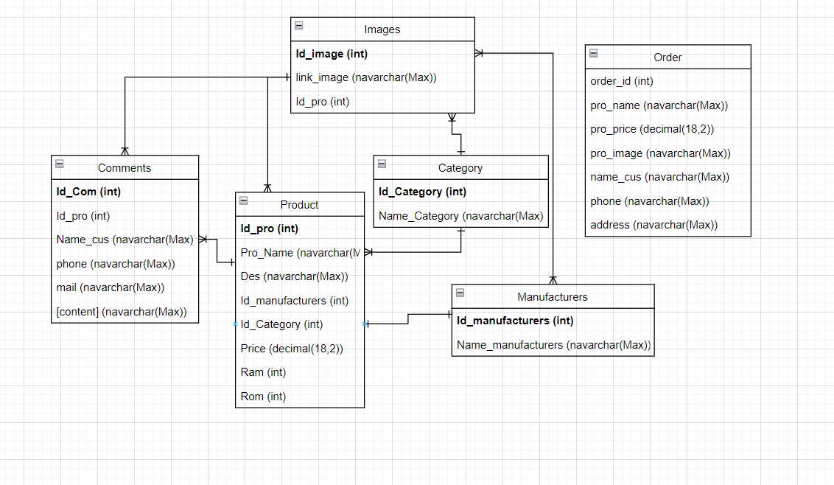

# Figure 2 – Thegioididong Store System Class Diagram

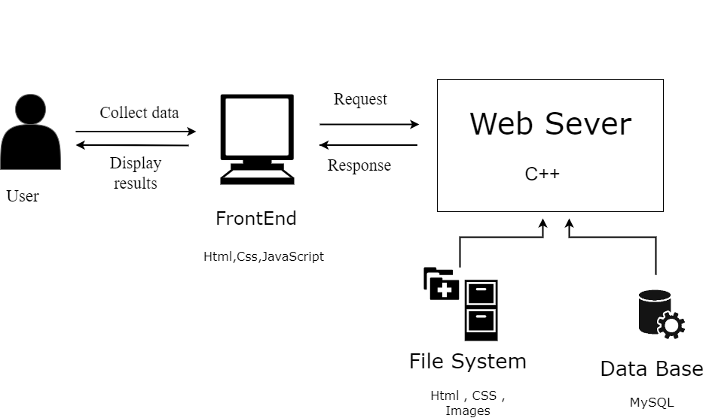

# Figure 3 – Thegioididong Store System architecture

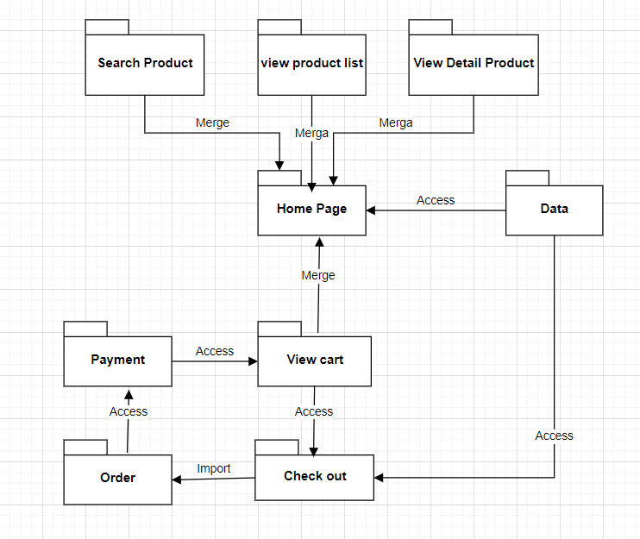

# Figure 4 – Thegioididong Store System Package